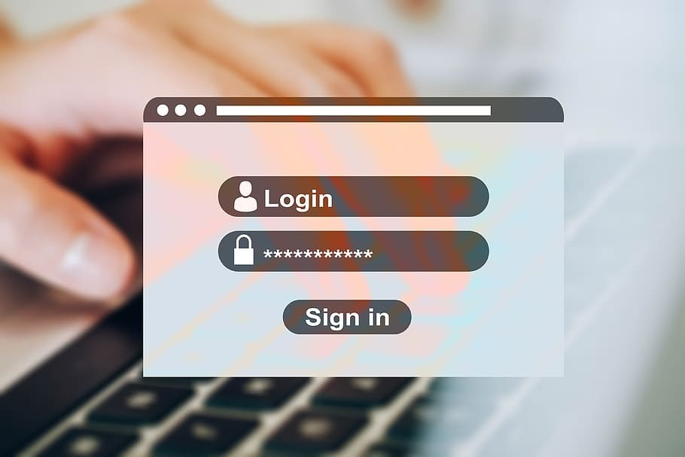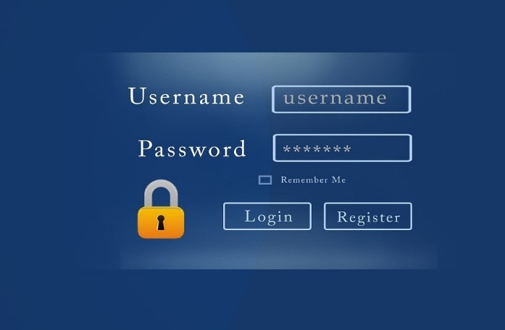****

***LOGIN AND***

***REGISTRATION SYSTEM***

**Team members:**

**Lauren Alana D’souza -4NM20CM016**

**Megha S -4NM20CM022**

**Sushmitha M -4NM20CM041**

**Requirements:**



**The login page and register page should provide two text fields respectively - one for entering the user name and one for entering the password.**

**In the login page if either of the text fields has an error that must be reported to the user.**

**If both fields are filled in but there is no record of the user name or the password that must also be reported to the user**

**Users that have not yet registered cannot log in. They must first register by clicking on the register option.**

**Registration only happens the first time you access the system.  It is a way to check your credentials.**

**Every time after your initial registration, you will log in to the system using the username and password you created.**

**In case the user has forgotten the user name or password, the user can search his Id by entering his username or password.**

IDE tool that we used: **Dev-C++**

**Design:**



**The aim of the project is to automate the existing manual system by the help of computerized equipments and full-fledged computer software,fullfilling their requirements,so that their valuable data/information can be stored for a longer period with easy accessing and manipulation of the same.So basically the project provides better service and easily used by the users..**

**The main objective of this project is to manage the details of username,password,login and registration.The purpose of the project is to build an application program to reduce the manual work for managing the username,password.**

**In this project we have to create three functions namely login,registration and other one called forget.(if the user forgets his username or password …this option will help him/her to login even if he/she forgets password!)We may also need header file called ifstream which is used to handle files..this is because all the username and password input by the user will be stored in one file..so inorder to access those files we need this headerfile!we can edit,add and update the records ,which results in proper resource management of username data..we may need to use simple switch case statement and while loop..**

**This project helps to maintain all the records input by the user such as username and password.**

**Role and responsibilities of the group members:**



* **Team members carry out the team’s work,sharing their knowledge and experience, listening to others and completing the project.**
* **Help in selecting, defining and developing the project**
* **They contribute fully to the project.**
* **They participate in the meetings and discussions.**
* **They listen to others and stay open to ideas.**
* **They communicate effectively with their teammates.**
* **Should make sure that the project selected must be agreed upon by all.**
* **Orient the team during the project.**
* **Learn tools/skills together with teammates.**
* **Identify problems/errors in the project.**
* **Contributing to overall project objectives**
* **Approving all changes to the project scope**

**All three of us have successfully done and will do the above roles and responsibilities.**